Nepal College of Information Technology
Assessment
Fall 2011
Program : BE ELX/IT/CE Time : 3 hrs
Semester : Fall (III) FM : 100
Subject : Engineering Math-III PM : 50
- Candidates are requested to give their answer as far as practicable in their own words.
- The figure in the margin indicates the full marks
- Attempt ALL question
1. a) Show that
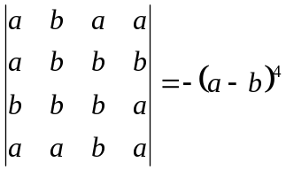 8
b) Slove by using Gauss elimination method:
x+y+z=3
x+2y+3z=4
2x+3y+4z=7 7
2. a) Define rank of a matrix. Find the rank of
A=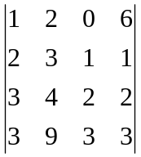 7
b) Find the eigen value and eigen vector of
B=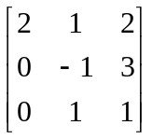 8
3. a) State and prove p-test series
OR
Find the expansion of 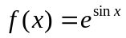by using Maclaurins’s expansion. 7
b) Check the convergent or divergent of 4*2=8
i) 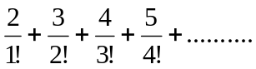
ii) 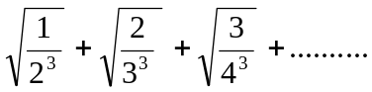
4. a) Find the fourier series of f(x)=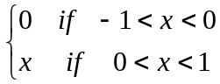 7
b) Find the fourier series of f(x)=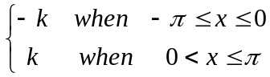
and show that 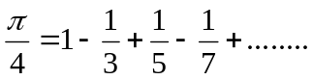 8
5. a) Show that the necessary and sufficient condition for the vector valued function of the scalar variable t to have a constant magnitude is 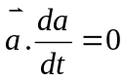 7
b) Find the directional derivative of the function f=x²-y²+2z² at point p(1, 2, 3) in the direction 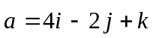. In what direction it will be maximum? 8
6. a) Show that the value under integral sign 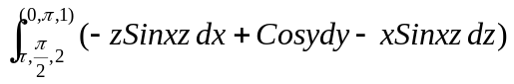is exact and evaluate the integral. 8
OR
Evaluate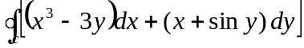, C: the boundary of the triangle with vertices (0,0) (1,0) , (0,2) counterclockwise.
b) Find the work done in moving a particle in the force field 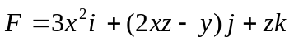 along the curve defined by x²=4y, 3x³=8z from x=0 to x=2. 7
7. Attempt all the questions:- 2*5=10
i) Define symmetric matrix with example.
ii) Check dependency and independency of the vectors u₁=(1,2), u₂=(1,3).
iii) Check the convergent of divergent series of 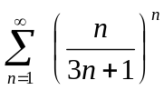
iv) Find a unit normal to the surface xy³z²=4 at (-1,-1,2)

v) Show that product of two odd functions is even.

